Name (in Romaji):
Student Number:
Class Day + Period:

MAD LIBS (WORD LIBS)

What are Mad Libs (often generically called Word Libs)? According to Mad Libs Online (2025), these are just one in a series of word-entry games that people have played since the early 1900s. One game, Revelations About My Friends, is a good example. This game, which was released by Frederick A. Stokes Companies in 1912, asks readers to insert words from different categories into blanks in order to create a story. There are many other games like this, including Consequences and Exquisite Corpse, but Mad Libs (sometimes written MadLibs) have popularized the word-entry game form with books and puzzles for all ages.

Reference
Mad Libs Online (2025). The Word Finder. Retrieved May 1, 2025, from https://www.thewordfinder.com/wordlibs/

Go to this website: https://www.thewordfinder.com/wordlibs/ . You will find many fun Mad Libs stories. Look at the example “The Great Gemstone Journey” below.

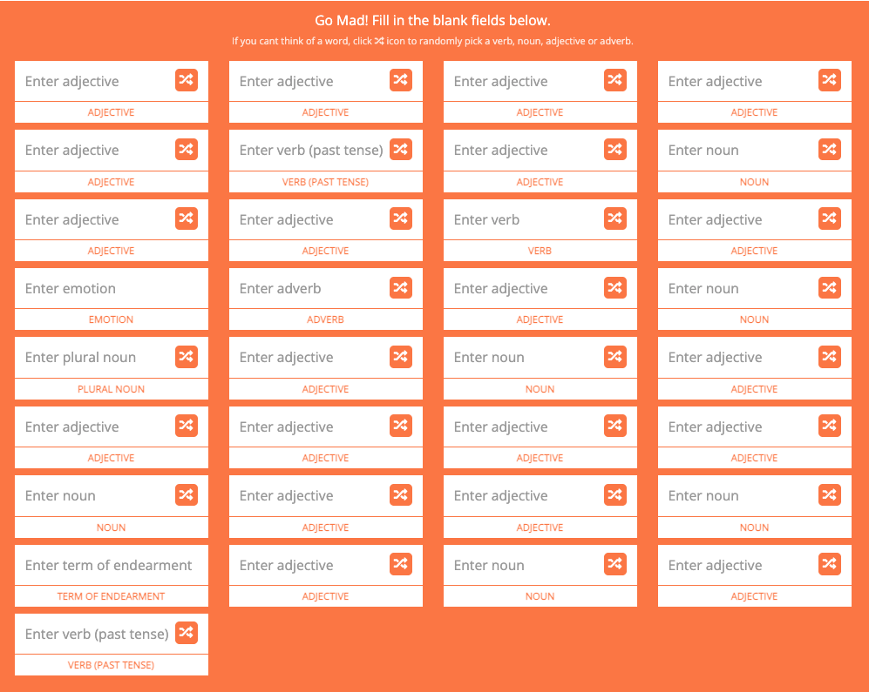 | 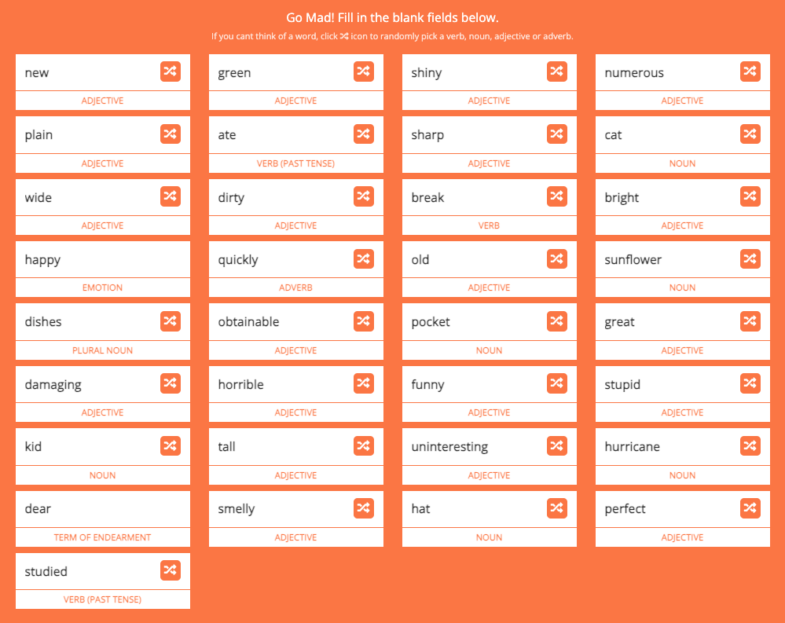
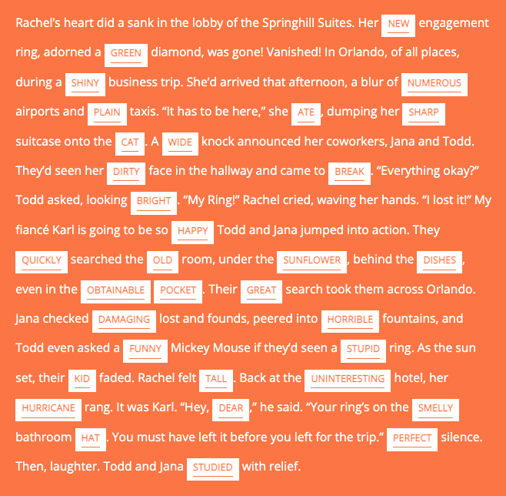  ____________________________________________  ____________________________________________  ____________________________________________  ____________________________________________  ____________________________________________ |  | For this Mad Libs, with a classmate, rate each inserted word on a traffic light scale.  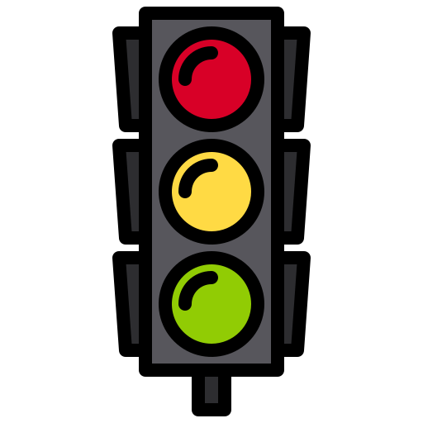  RED = the inserted word does not grammatically work, or it makes no sense (ex: a wide knock; …and came to break)  YELLOW = the inserted word somewhat works grammatically or kind of makes sense, but something is still strange (ex: her hurricane rang)  GREEN = this inserted word grammatically makes sense or works very well in this context (ex: her new engagement ring)  BLUE = BONUS: add this to the color of the inserted words that you found particularly funny (ex: under the sunflower)

______________________________________________________________________________

______________________________________________________________________________

______________________________________________________________________________

______________________________________________________________________________

